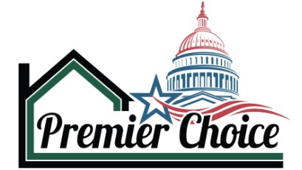
FEDERAL CAPABILITY STATEMENT
EXECUTIVE SUMMARY

- Duns #: 09-535-8471
- Company Type: Limited Liability
- Incorporated: 2016
- Bonding Capacity Single Project $5 million
- Bonding Capacity Aggregate: $20 million
- EMR Score .97
- Insurance Coverages Carried
  - General Liability
  - Automotive
  - Workers Compensation
  - Umbrella / Excess Liability
  - Pollution

- Certified Professional Contract Managers
- Certified Project Management Professionals
- 40-Hour General Requirements Certification for EM-385-1-1
- 24-Hour Fall Protection Competent Person

238160: Roofing Contractors
238310: Drywall & Insulation
238320: Painting & Wall Covering
238130: Framing Contractors
238350: Finish Carpentry
238110: Poured Concrete Foundation
238140: Masonry
238390: Other Building Finishing
238340: Tile and Terrazzo
562910: Remediation Services
238210: Electrical Wiring
238220: Plumbing, Heating, and Air

4580 Mack Avenue
- Suite: G
Frederick, MD 21703
- (240) 815-6032 | Office
 Info@PremierChoiceExteriors.com
 www.PremierChoiceExteriors.com

PREMIER CHOICE
4580 Mack Avenue, Suite G
Frederick, MD 21703
240) 815-6032
STEVE LYONS
SLyons@Premierchoiceexteriors.com
www.premierchoiceexteriors.com

BUSINESS OVERVIEW:
CONTACT INFO:
NAICS CODES:
INDUSTRY CERTIFICATIONS:
Premier Choice Exteriors, LLC DBA Premier Choice Services specializes in delivering high-quality construction solutions for federal general contractors. Since 2017, we have built a proven track record of managing all aspects of construction projects with a focus on quality, timely delivery, and compliance. Leveraging certified professionals and advanced project management tools, we act as an extension of your team, ensuring projects are completed on time, within budget, and to federal standards. Our unwavering commitment to safety and client satisfaction makes us a dependable partner for all your construction needs.
CORE COMPETENCIES
- Joint Base Langley
- Naval Station Norfolk
- USCG Station – Ocean City
- Smithsonian
- National Zoo
- Camp Lejeune

- Fort Belvoir
- Kings Bay
- Andrews Airforce Base
- Dover Airforce Base
- Fort Meade
- Fort Detrick

SOLUTIONS
- Design Build
- High Performance Cladding
- Grading (Water Runoff)
- Green Roof
- High Efficiency Systems
  - Lighting
  - Water Heater
  - HVAC

PAST PERFORMANCE
SERVICES
- Design build capabilities
- Strong past performance
- Quality assurance management process
- Understanding of how to deliver best value at winning price
- Clear pricing and multi-vendor relationships to control cost
- Management team with over 200 years of combined experience

- Roofing
- Exterior Applications
- Painting
- Masonry Restoration
- Concrete Flatwork
- Interior Finishes
- Building Systems
- Restoration (Fire & Water)

KEY DIFFERENTIATORS

